**DAILY ONLINE ACTIVITIES SUMMARY**

|  |  |  |  |  |  |  |  |
| --- | --- | --- | --- | --- | --- | --- | --- |
| **Date:** | **09/06/2020** | | | | **Name:** | **Tushit Shukla** | |
| **Sem & Sec** | **4 sem & B sec** | | | | **USN:** | **4AL18CS093** | |
| **Online Test Summary** | | | | | | | |
| **Subject** | | - | | | | | |
| **Max. Marks** | | - | | **Score** | | - | |
| **Certification Course Summary** | | | | | | | |
| **Course** | 1. Java programing | | | | | | |
| **Certificate Provider** | | | **Great Learning** | **Duration** | | | **1s hr(spent by me on that day to learn)** |
| **Coding Challenges** | | | | | | | |
| **Problem Statement:**   1. Rotate the matrix by K times means rotating the given NN matrix to the specified (K) number of times. For example, consider the 33 matrix, which has to be rotated once, Enter the Size of the Matrix: 3, 3 Enter the Elements of the Matrix: 10, 20, 39, 40, 50, 60, 70, 80, 90 Enter the value of K (Number of Rotations): 1 Matrix before Rotation: 10 20 30 40 50 60 70 80 90 Matrix after Rotation: 20 30 10 50 60 40 80 90 70 | | | | | | | |
| **Status: Completed** | | | | | | | |
| **Uploaded the report in Github** | | | | **Yes** | | | |
| **If yes Repository name** | | | | <https://github.com/tushitshukla29/lockdown-program> | | | |
| **Uploaded the report in slack** | | | | **Yes** | | | |

**Online Certification Details**:

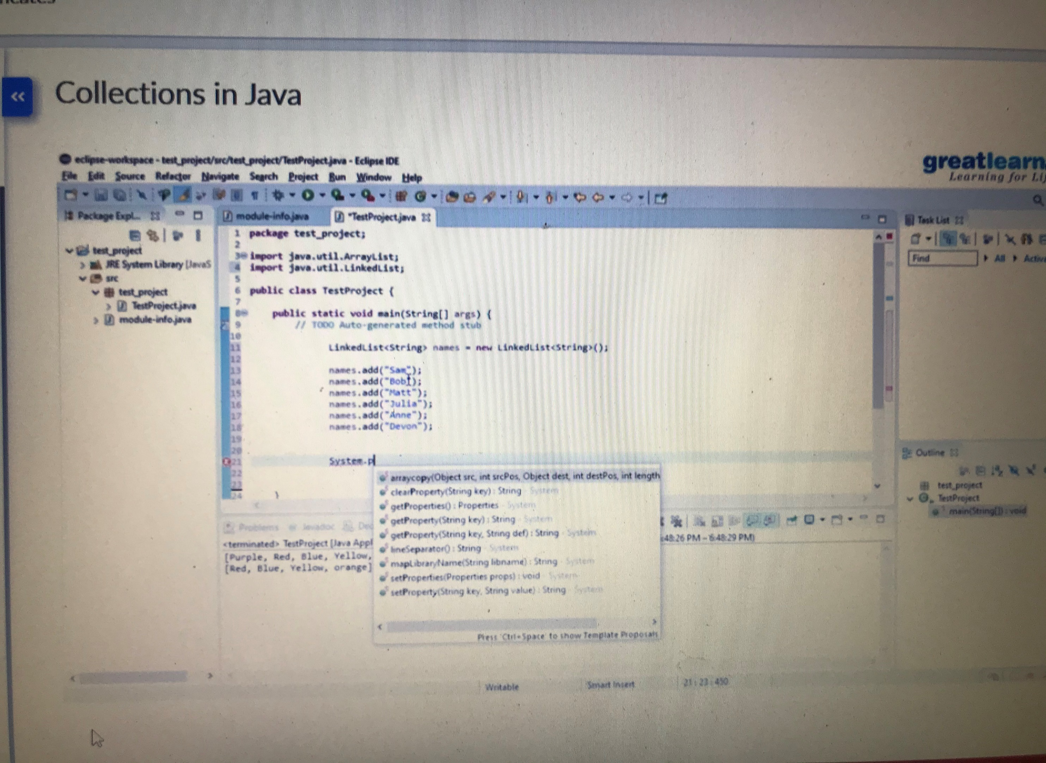

**Coding Challenge Detail :** I have written programs and uploaded it to my Github repository.

Link as follows: <https://github.com/tushitshukla29/lockdown-program/blob/master/rotationmatrix>